**Weekly Status Update for Mid-break 1**

**Timeline:** From 03-04-2024 to 10-04-2024

**What we have done:**

Backend

* [Add new user role type for institution](https://github.com/perspicacious-slinki/Immutable2024s1ANUTechlauncher/issues/186) Nuoxi Done

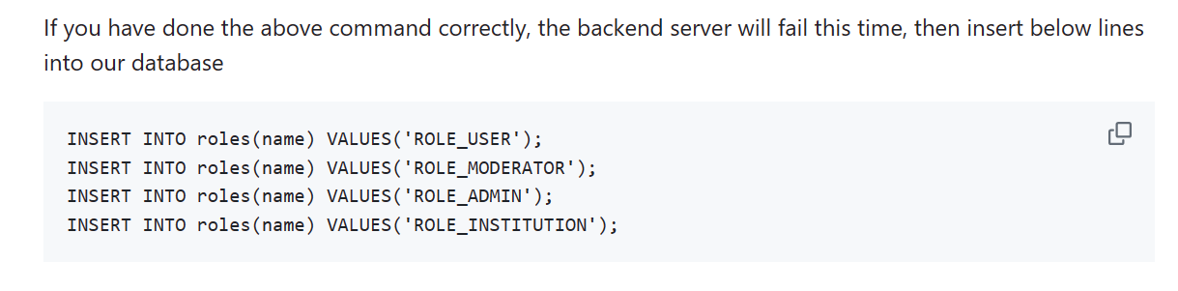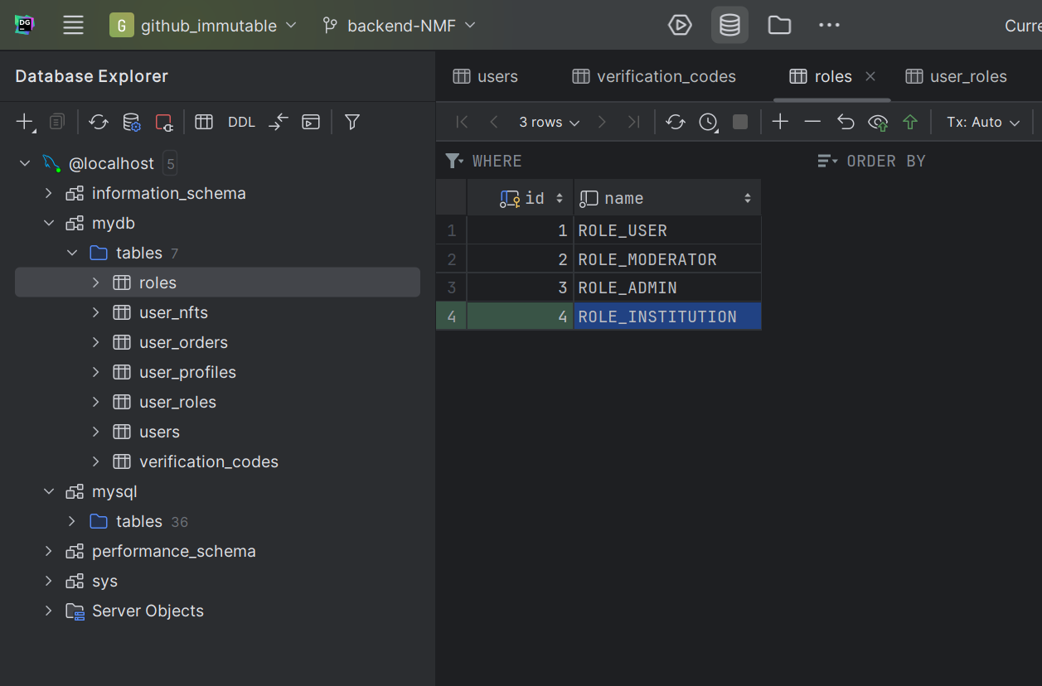

* [Configuring the backend for storing images](https://github.com/perspicacious-slinki/Immutable2024s1ANUTechlauncher/issues/187) Songxun Done
* [Link the provider field in the Order request to the Institutions.](https://github.com/perspicacious-slinki/Immutable2024s1ANUTechlauncher/issues/188) Andy

Frontend

* [The admin board need displays the returned data](https://github.com/perspicacious-slinki/Immutable2024s1ANUTechlauncher/issues/185) Bohong
* [The Request List needs to display the appropriate fields](https://github.com/perspicacious-slinki/Immutable2024s1ANUTechlauncher/issues/182) Bohong Done
* [NFT request form Two images not transferring to backend](https://github.com/perspicacious-slinki/Immutable2024s1ANUTechlauncher/issues/181) Linxi Done
* [Automatic Duplication of Uploaded Image in Separate Form Fields](https://github.com/perspicacious-slinki/Immutable2024s1ANUTechlauncher/issues/179) Linxi Done

**This week plan for backend and frontend:**

|  |  |  |
| --- | --- | --- |
| **Action Item** | **Responsible Party** | **Due Date** |
| Build initial front end of Institution request page | Linxi | 17/04/2024 |
| Build initial front end of Institution 'admin' page | Bohong | 17/04/2024 |
| Create function for getting all the data of a single, existing NFT request to the frontend layer | Songxuan | 17/04/2024 |
| Create function for getting all pending NFT requests that are associated with an institutions email to the frontend layer | Andy | 17/04/2024 |
| Review existing modules of code for automaticlly sending email to users | Nuoxi | 17/04/2024 |